# Executive Summary

The data analytics team has been approached by the sales and marketing teams to analyze data of buyers in their retail store and generate insights for strategizing an effective and efficient marketing campaign. Three objectives have been formed to achieve in the analysis. First, they need to identify the top three products to choose as promotional items during the campaign. Second, the teams want to set appropriate minimum order for each of the top three items so that a maximum number of customers are able to get discounts. In addition, the sales and marketing teams aim to increase the number of buyers in three purchase channels, including website, catalogue order and in-store visits, by designing an advertisement that targets people with a certain range of yearly income. Therefore, to make sure that the advertisement is effective, the last objective is to explore whether there is a correlation between buyers’ incomes and their behavior of using purchase channels.

To find the top three products for promotions, a simple method is to look at the performance of the products in the retail store by analyzing the demand intensity and profit generation. After ranking the products, a closer look on the most frequent range of customers’ spending will help the marketing and sales team to decide on the minimum value per order which a customer has to spend to get a discount. In terms of exploring relationship between incomes–which is an independent variable–and purchase channel–which is a dependent variable–scatter plots are used to illustrate the correlation between the two variables.

After observing the demand intensity and comparing total profits made from the sale of the five products, the top three products have been identified which include wine, meat and fish. The frequencies of spending range made within each of the top three products indicate the minimum amount of order as follows: $100 for wine; $115 for meat; and $17 for fish. Finally, it was found that buyers’ incomes and their behavior of using purchase channels are somehow correlated, but the relationship between them is not great. Therefore, incomes do not have much influence on the purchase behavior of the buyers.

From insights drawn from the data analysis, some key actions are recommended as the followings:

• The top three products the sales and marketing teams should select for the promotional campaign are wine, meat and fish.

• In order to allow a large number of customers to get discounts for the prioritized products, the teams should set the minimum order of wine to $100, meat to $115, and fish to $17.

• Income is not the sole factor that drives buyers' behavior in using purchase channels. Therefore, the teams should consider other traits and attributes of buyers to shape the targeted advertisement effectively.

# Analysis Plan

## Industry of Focus

* Retail store

## Business Case

Sales and marketing teams of a retail store are planning a marketing campaign to retain the existing customers and attract new ones. To spend the marketing budget efficiently and effectively, they have to decide what top three products should be prioritized for next promotions. Moreover, one of the promotions they have planned is giving discounts to buyers who have purchased each of the top three products under certain amount of money. To proceed with the promotion, they need help from the data analytics team to look into the record of buyers and find out the minimum order of the prioritized products. In addition, the sales and marketing teams aim to increase the number of buyers in three purchase channels, including website, catalogue order and in-store visits, by designing an advertisement that targets people with a certain range of yearly income. However, it is not certain whether the income range of buyers could affect their choices of using a purchase channel, or vice versa. Therefore, the last assignment for the data analytics team is to explore whether there is a correlation between buyers’ incomes and their behavior of using purchase channels.

## Business Questions

* What are the top three products eligible for promotions?
* What should be the minimum order which a customer has to spend to get a discount?
* Is there a relationship between buyers’ income and their use of purchase channel?

## Key Stakeholders

* Marketing Team
* Sales Team
* Data Analytics Team

1. **Dataset**

* Marketing Analytics: Practice Exploratory and Statistical Analysis with Marketing Data
  + Sources: <https://www.kaggle.com/jackdaoud/marketing-data>
* The data are usable and do not require cleaning.



## Key Performance Indicators and Metrics

To find the top three products for promotions, a simple method is to look at the performance of our products in the retail store. The analysis on product performance can be based on two Key Performance Indicators (KPIs), which include demand intensity and profit generation. In a general sense, a product having high demand is inherently a good sign for business, but it should also be able to yield most profit so that the business could generate more income. Therefore, a good-performing product should have a high number of demand, as well as the ability to generate more profit.

In the analysis, the metrics used to observe the demand intensity is the percentage of buyers who spent above the average amount of purchases of a certain product. To find the average purchase amount, the mean is calculated based on the data points of purchases made by each buyer. Also, all data points of the purchase amount per product are totaled up so that profit comparison among products can be made.



After ranking the products, a closer look on the most frequent range of customers’ spending will help the marketing and sales team to decide on the minimum value per order which a customer has to spend to get a discount. Therefore, the frequency of spending range is used as the metrics to determine the minimum order of the top three products.

In terms of exploring relationship between incomes–which is an independent variable–and purchase channel–which is a dependent variable–scatter plots are used to illustrate the correlation between the two variables. In addition, R-square (R2) values are also observed to assess the significance of the relationship. For the sake of simplicity, an R2 value less than 80% will consider the relationship weak.

## Tools

* Excel

# Analysis

## Dataset

## Findings

### Prioritized Products

The graph below depicts the demand intensity illustrated in percentages of customers who spent above the average purchase amount of the five products. It shows that wine has the highest percentage, amounted to 38.57%. The second highest one is meat, which has 31.29% of demand, followed by fish with 29.69%.

According to the graph, wine was the best-selling product, which generated a total sale of $680,816. The second biggest sale was meat product, making $373,968 worth of revenue. Even though the sale of fish made only $84,057, it was the third biggest source of revenue compared to sweet and fruit products.

With the analysis on the demand intensity and total profits, the products eligible for the next marketing campaign are ranked accordingly: **1. Wine; 2. Meat; 3. Fish**.

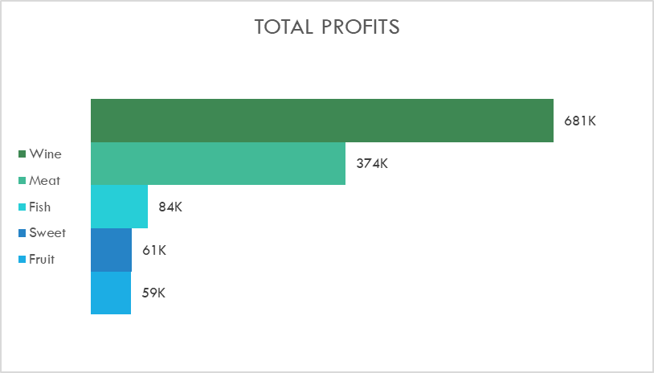

### Minimum Order

Based on the three graphs showing the frequency of spending range, it indicates that customers most commonly made purchases of wine and meat products under $100 and $115, with the frequencies of 947 and 1,373, respectively. For the fish product, the most popular spending is under $17, with the frequency of 1,291. Therefore, to satisfy the maximum number of customers, the teams should set the minimum order of wine under 100$, meat under $115, and fish under $17, so that most of the customers will be able to get discounts.

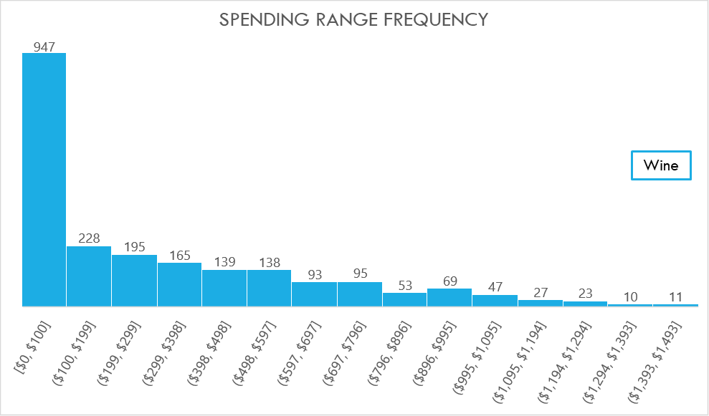

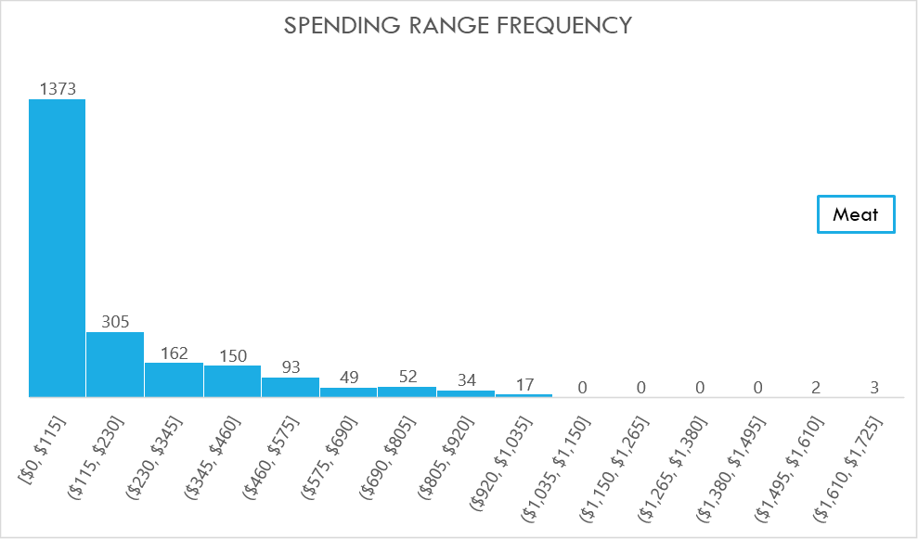

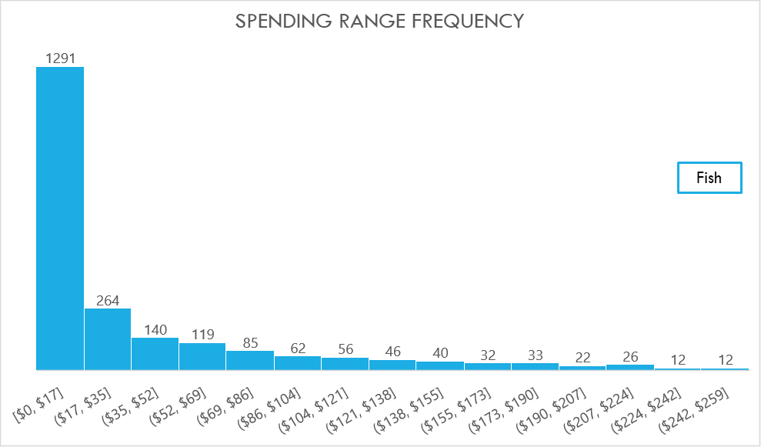

### Purchase Behavior

With the scatter plot comparing data points of the income range and the number of purchases via catalogue, it shows that there is a relationship between the two variables. For instance, the number of catalogue purchases relatively increase as the incomes of buyers are higher. However, the R2 value is only 0.49 or 49%, indicating that the relationship is weak. Even though incomes can influence buyers’ behavior in catalogue purchases to a certain extent, the influence itself is not significant or strong enough. In other words, the influence is not applied for every buyer in the sample since there is an instance that a buyer with low incomes, which is less than $5000, made purchases via catalogue more than that of the rest of the buyers. Also, the buyers who have the yearly income of around $16,0000, which is the highest of all, did not use any catalogue purchase at all.

The influence also exists among web purchases and store purchases, in which higher incomes corresponds to the higher of number of purchases made in store and via website. Still, the influence of incomes on the purchase behavior in both channel is not great, as the R2 values of the income range compared with store purchases are only 40%, and with web purchases only 21%.

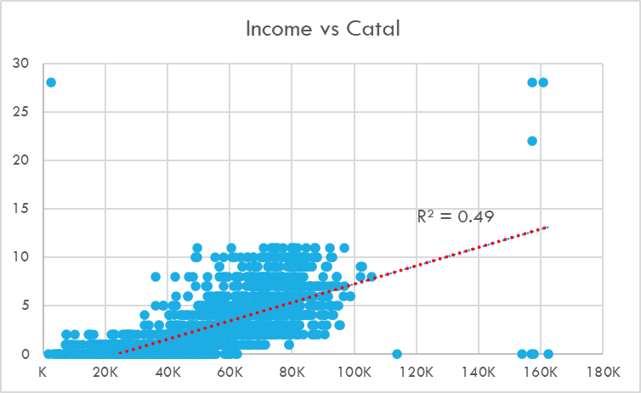

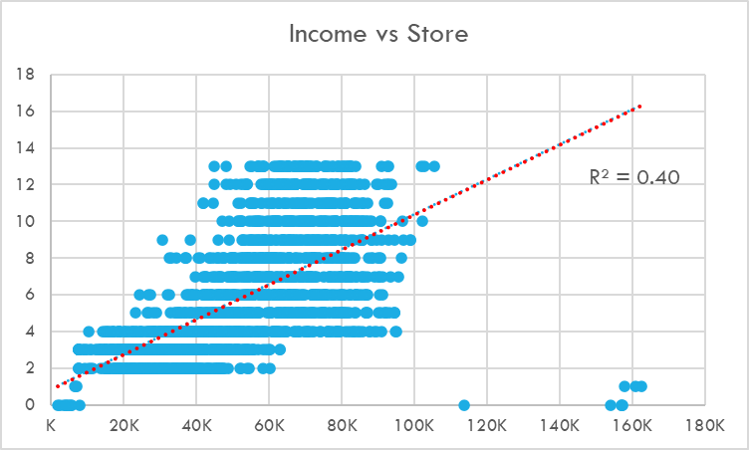

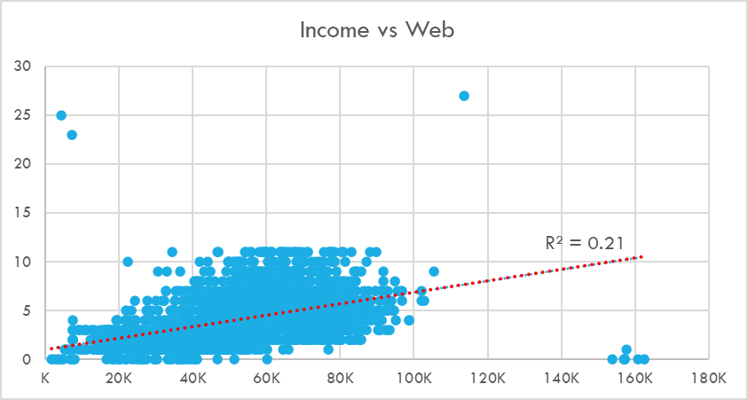

# Conclusion

With the analysis on the data points gathered from buyers in the dataset, key findings and insights have been discovered to answer the key business questions. By observing the demand intensity and comparing total profits made from the sale of the five products, the top three products have been identified which include wine, meat and fish. At the same time, the frequencies of spending range made within each of the top three products indicate the minimum amount of order as follows: $100 for wine; $115 for meat; and $17 for fish. Finally, after exploring buyers' data on their yearly incomes and their number of purchases in website, catalogue order and in-store visits, it was found that the two variables are somehow correlated, but the relationship between them is not great. In other words, incomes do not have much influence on the purchase behavior of the buyers.

# Recommendations

From insights drawn from the data analysis, some key actions are recommended as the followings:

* The top three products the sales and marketing teams should select for the promotional campaign are wine, meat and fish.
* In order to allow a large number of customers to get discounts for the prioritized products, the teams should set the minimum order of wine to $100, meat to $115, and fish to $17.
* Income is not the sole factor that drives buyers' behavior in using purchase channels. Therefore, the teams should consider other traits and attributes of buyers to shape the targeted advertisement effectively.

I. Executive Summary

II. Analysis Plan

1. Industry of Focus

2. Business Case

3. Business Questions

4. Key Stakeholders

6. Key Performance Indicators and Metrics

7. Tools

III. Analysis

1. Dataset

2. Findings

Prioritized Products

Minimum Order

Purchase Behavior

IV. Conclusion

V. Recommendations